1. Agenda:
   1. Reading configurations from a file system.
2. Why?
   1. Maybe property file contains some sensitive info and you don’t want to expose it into version control system (GitHub).
3. 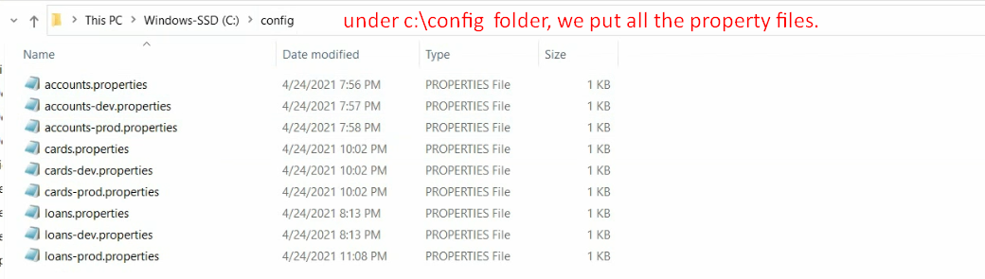
4. 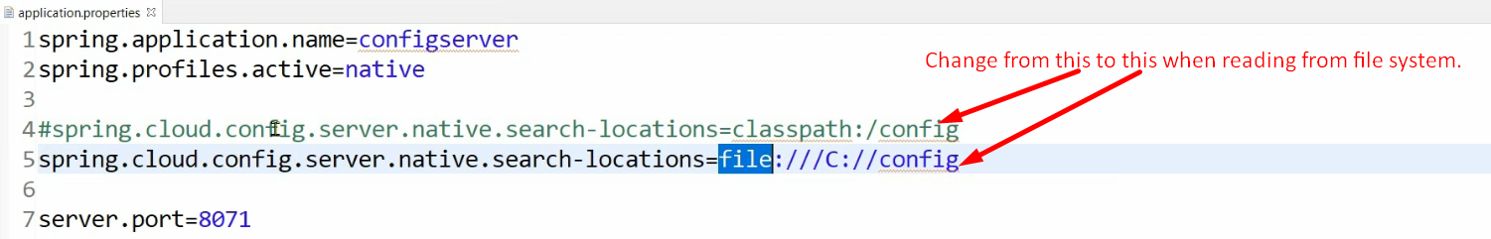
5. 